USER MANUAL
BABY FOOD PROCESSOR

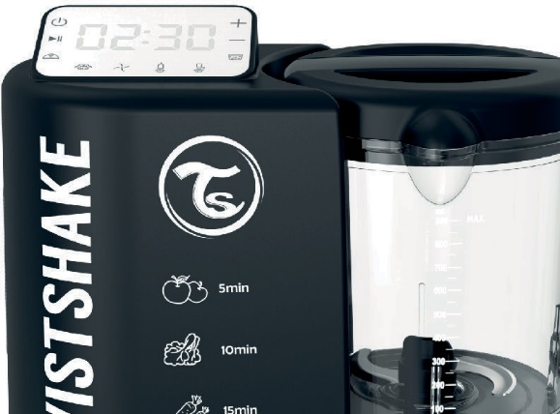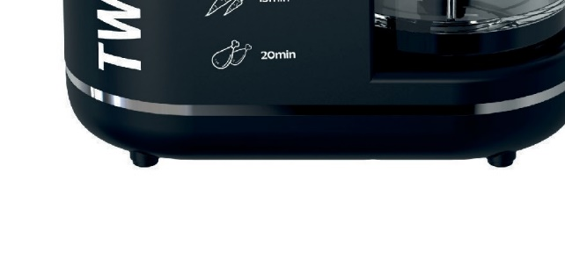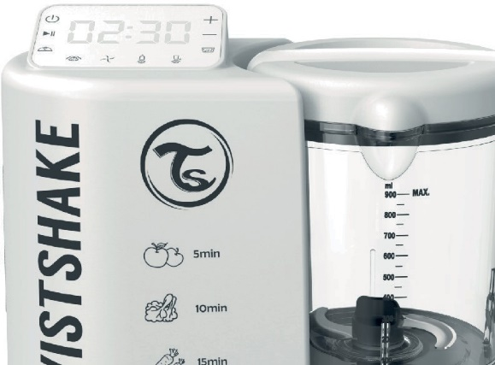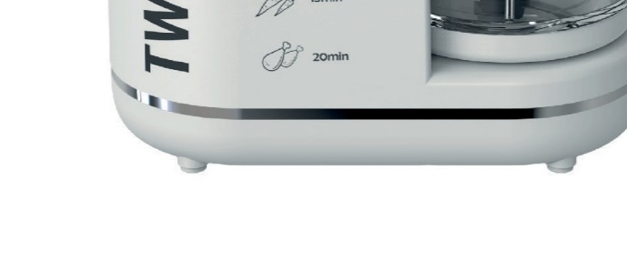

VISIT WWW.TWISTSHAKE.COM
FOR INSTRUCTION-VIDEO EN/SE/ES/FR

- INTRODUCTION

Congratulations on the purchase of this digital baby food processor that combines a steamer, blender/chopper, heater and sterilizer.
This appliance is particularly suitable for sterilizing bottles and accessories and for preparing baby food. Before using this device, please read the instructions in this manual carefully. Please keep in a safe place as it contains important information.
The features described in this user's guide are subject to modifications without prior notice

- SAFETY INSTRUCTION WARNINGS

The following precautions must be taken each time an electrical appliance is used and particularly when children are present.

Be careful if hot liquid are poured into the food processor or blender as it can be ejected out of the appliance due to sudden steaming.

Always disconnect the appliance from the power supply if unattended and before assembling, disassembling or cleaning.

Children should be supervised to ensure that they do not play with the appliance. Keep the appliance and the cord out of reach from children.

This appliance is not intended to be used by persons (including children) with reduced physical, sensory or mental capabilities, lack of experience and knowledge unless they are under supervision during the whole operation on.
If the power cord is damaged, it must be replaced by the manufacturer, service agent or other qualified person in order to avoid accidents to occur.
Never use the appliance if the plug, cord, casing or if the appliance itself is damaged. Handle the blades with great care, particularly when you empty or clean the jar.
If the blades get blocked, always unplug the appliance before removing the cause of the blockage.
- The appliance gets very hot during steam cooking and may cause burning in the event of contact.
- Beware of the hot steam that rises from the bowl and water tank during cooking and when you remove the lid.
Never leave the appliance on without supervision.
This appliance is intended to be used in a domestic household environment. Always use the handle to lift the bowl.

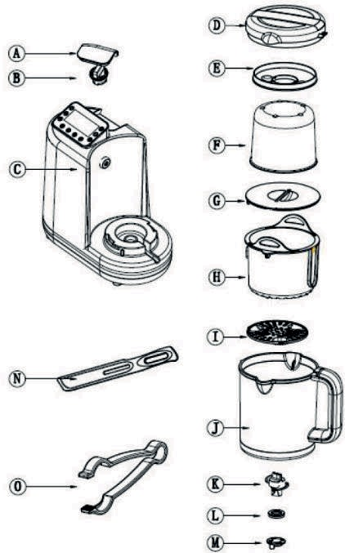
- DESCRIPTION

  - PARTS DESCRIPTION (Figure 1)

- Water tank lid
- Water tank cap
- Casing and digital control panel
- Jar lid
- Heat insulation cover
- Measuring cup
- Splash Lid
- Steaming basket
- Strainer
- Blender jug
- Blade
- Blade sealing gasket M . Blade base
N. Spatula
0. Pinchers

  - TOUCH CONTROL PANEL (Figure 2)

- ON/OFF
- Start/Pause
- Steaming function
- Blending function
- Heater Function
- Sterilizer Function
- Keep warm
- Descaling
- Increase time
- Decrease time
V. Empty water tank indicator

Figure 1

1 - (0 .,,. ,r, +- 9
2 - II •.JC·:u._1 - - 10
7 - i:t:. lt. - 8
V- • Q ijJ,

I I I I
3 4 5 6
Figure 2

Water level window (Figure 3)

The left side of water tank shows water level (ml) .
The right side shows an estimate of how many minutes of steam cooking the water level allows

Figure 3

- INSTRUCTIONS FOR USE

  - BEFORE USING

    - UNPACK AND CLEAN
Before first usage carefully clean the jar, the blades, the cooking baskets, the lids,
The strainer, the spatula and the clamp with a sponge in soapy water or in the dishwasher.

    - FILLING THE WATER TANK (Figure 4-Figure 6)
- Remove the water tank lid (A) by pulling it up as shown below.
- Open the water tank by turning the cap (B) anticlockwise.
- Fill the tank with water using the Measuring Cup (F)
- Close the water tank by turning the cap (B) clockwise.
- Put the lid (A) on to the tank nozzle and carefully press the lid down.

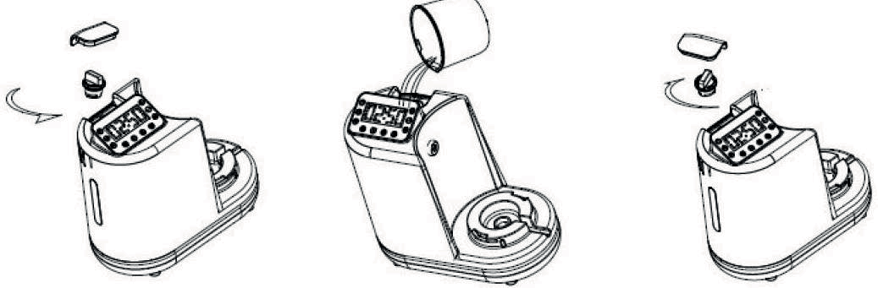
Figure 4 Figure 5 Figure 6

    - BLENDER JAR PLACEMENT
- Before use, make sure the blender jar fits correctly.
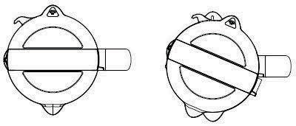
- If you want to use the jug lid, just fit the jug lid on the blender jar and turn anticlockwise, make sure the hook of the lid is fully inserted in the hold on the housing.

Figure 7

    - INSTALLING AND REMOVING THE BLADE
- Hold the blade (K) upside-down (as shown) and position the seal (L) with the suction pad facing upwards.
- Push the seal (L) onto the blade spindle.
- Hold the blender jar (J) upside-down and insert the blade's spindle into the hole inside the blender jar. Place the locking ring (M) on to the blade's spindle, while holding the blade in position inside the blender jug (J).
- Twist the locking ring (M) a quarter turn anticlockwise to secure that the blad are in place.
Important! Pull the locking ring (M) to ensure that the blade is properly attached before operation!

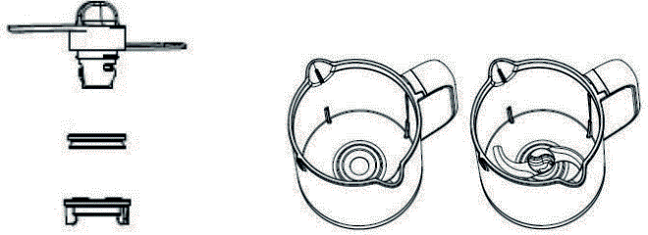
Figure 8 Figure 9

    - ANTI-DRY PROTECTION
Once the water tank is empty during steaming/heating/sterilizing, the empty water tank indicator on the control panel will flash and a buzzer will sound for 10 minutes.
As soon as fresh water is added into the tank the indicator and buzzer will stop and the appliance can be restarted and operation resumed.
FUNCTIONS 4.2.
STEAMING G
- Fill the water tank (refer to 5.1.2.)
- Place the food into the steam basket (H).
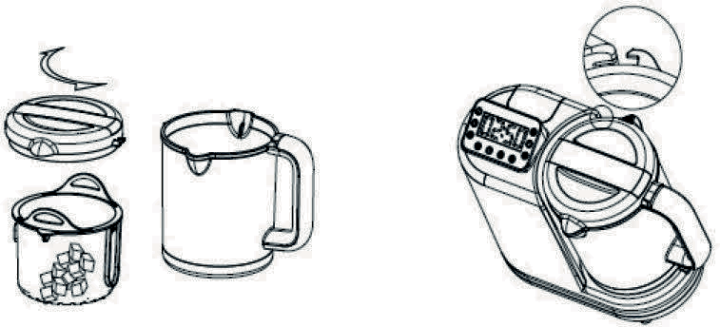
- If you want to steam only one food at a time, just put the food into the steaming basket and place the basket into the blender jar, put the jug lid at place and turn it anticlockwise into the handle (Figure O). Before starting to steam, turn the buckle on the jug lid into the housing.
(Figure 11)

Figure 10 Figure 11

- If you want to steam two different foods at one time, put the first food into the steaming basket and insert the basket into the blender jug. Put the second food into the measuring cup and put the strainer in place as shown below. Place the measuring cup over the steaming basket.
(Figure 12--Figure 14)
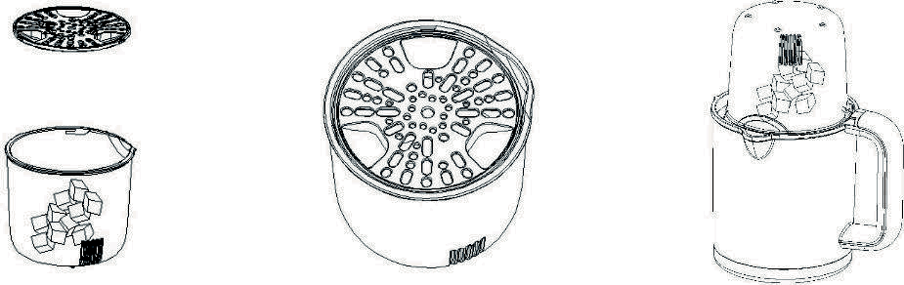
Figure 12 Figure 13 Figure 14

- Press the steam button on the display.
5.1 The default setting is 20 minutes steaming, you can press on the display to increase or decrease the steaming time (between 1 minute and 30 minutes). Once the cooking time is set, press start to start the cooking process. If you want to pause the machine during cooking,

When you wish to resume the steaming press

- When cooking is completed, the appliance beeps and a light will flash. The light will turn off after 5 minutes if there is no any further operation.
- Open the jar lid and pull out the steam basket by using the spatula(N).
- The food is ready to eat or to blend

Ingredients and steaming (for reference only)

Food Type | Food | Cooking Time
Fruit | Apple | 5 min.
 | Orange | 10 min.
 | Peach | 10 min.
 | Pear | 5 min.
 | Pineapple | 15 min.
 | Plum | 10 min.
Vegetables | Asparagus | 10 min.
 | Broccoli | 20 min.
 | Carrot | 15 min.
 | Cauliflower | 15 min.
 | Celery | 15 min.
 | Courgette | 15 min.
 | Fennel | 15 min.
 | French beans | 20 min.
 | Leek | 15 min.
 | Onion | 15 min.
 | Peas | 20 min.
 | Pepper | 15 min.
 | Potato | 20 min.
 | Pumpkin | 15 min.
 | Spinach | 15 min.
 | Swedes | 15 min.
 | Sweet potato | 15 min.
 | Tomato | 15 min.
Meat | Chicken, beef, lamb, pork etc. | 20 min.
Fish | Salmon, sole, cod, trout etc | 15 min.

Notes:
- All food must be cut in small pieces, no bigger than 2-3cm.
- The amount of water required to fill the tank in order to achieve a certain steaming time may vary according to the room temperature and/or the hardness and temperature of the water. The maximum level in the tank is suitable for steaming for 30 minutes.
If you require longer steaming sessions, follow below steps when the water in the tank is emptied: pause the operation and wait for 5 minutes
open the water tank
- fill with enough water to finish the steaming
- Press the button (2) to resume the steaming process.

  - BLENDING FUNCTION \
- Place the cooked or fresh food from the basket directly into the blender jar.(Figure 15- Figure 17)
- Put the splash lid (G) on and close the jar lid (D).

- Place the bowl on the base and lock into place.
- Plug in and turn on the appliance (C).
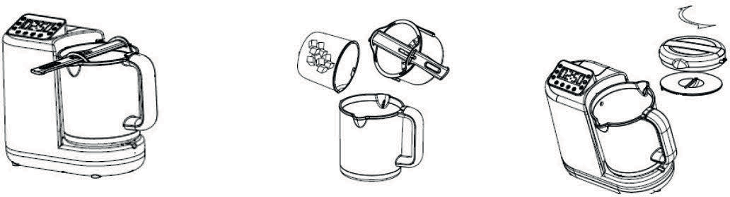
Default setting is 5 cycles. If you want to pause the operation you may press this button again. Each cycle is 13 seconds blending and 2 seconds off for each session.

Figure 15 Figure 16 Figure 17

Add the ingredients (such as water, milk, sugar, oil, etc) based on your need, and turn the jug lid anticlockwise. All foods and ingredients inside the blender jug should not exceed 900ml.
Guides and recommendation for blending:

Food | Maximum Quantity | Operating time (one cycle) | Maximum number of cycles
e.g. Carrots & water | 540g carrots & 360g water | 13s on & 2s off | s

Attention:
-When using the blending function, you need to put the food into the blender jug, place the splash cover over the blender jug, and follow the next step (Figure 18).
- Avoid blending when the jug is empty.
- Before using the blending function, make sure the blender jug fits correct ly. (The inlet hole on the side of the blender jug must line-up exactly with the steam outlet on the food processor). Fit the jar
lid on the blender jug and turn anticlockwise, make sure the hook of the lid is fully inserted in the hold on the housing.
- Press the blend button (4). Press the start button (2) to start the operation.
- If you want to pause the machine during bledning, . To resume blending, again after one cycle is finished, you may press start button again for an extra 12 seconds of blending.
- When blending is completed, a buzzer will sound and a light will flash. All lights will turn off after 5 minutes if there is no further operation.
- Scrape the foods out from blender jar by the spatula. (Figure 18 - Figure 20)
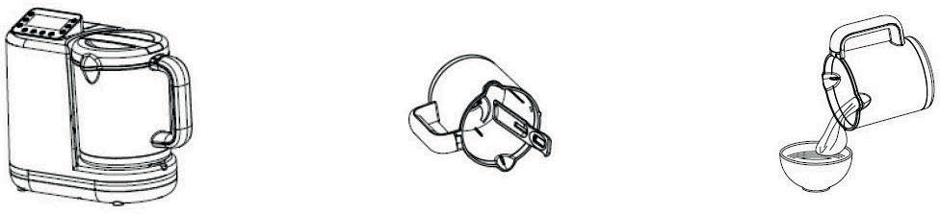

Figure 18

- Unplug the appliance
Figure 19 Figure 20

- Clean the blender jug after the blending is done.

  - STERILIZER (w.q
- Fill the tank with water.
- Place the blender jug onto the housing, twist it and then insert the steaming basket into the blender jar. (Figure 21)
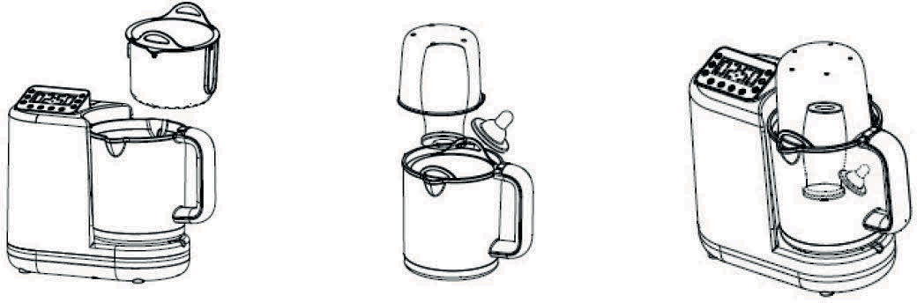
- Put the bottle upside down into the steaming basket, then cover it with the measuring cup. (Figure 22 - Figure 23)

Figure 21

- Sterilizer button \m.q
Figure 22 Figure 23

Press the sterilizer butt on. Default working time is 8 minutes. You may press the to increase or decrease the sterilizer time between 1 minute and 30 minut es. Once desired setting is chased, press the start button to start the sterilizing. If you want to pause the machine during the operation, press (w.q button again.
To continue the operation press start button
- Once the sterilizing is completed, a buzzer will sound 6 times and a light will flash. All lights will turn off after 5 minutes if there is no any further operation.
- Open the jug lid and take out the bottle by using the tong or gloves.(Figure 24)
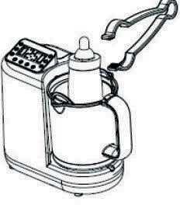
Figure 24

- Unplug the appliance

4.5. HEATING t\
- Fill the water tank with approx. 50ml water.
- Place the blender jug on the housing, twist it on and then insert the steaming basket into blender jug.(Figure 25)
- Put the bottle into the steam basket, and cover it with the measuring cup. (Figure 26 - Figure 27)

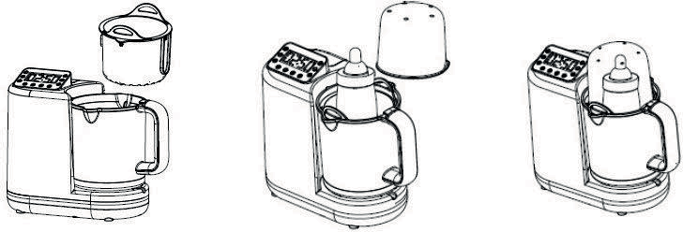
Figure 25 Figure 25 Figure 27

Food you may heat include baby milk, soup, juice, water and pre made baby food
- Heater button
Press the heater button, default cycle time is 3 minute s. You may press to increase or
decrease the heating time between 1 minute and 20 minutes. Once desired setting is chased, press the start button to start the operati on. If you want to pause the machine during operation, press the
button again. After pause, press to resume the operati on.
- Once heating is completed, a buzzer will sound 6 times, and a light will flash. All lights will turn off after 5 minutes if there is no any further operation.
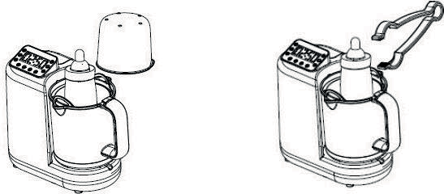
- Open the jug lid and take out the bottle by using the tong or gloves. (Figure 28-Figure 29)

Figure 28

- Unplug the appliance.
Figure 29

TABLES FOR HEATING

 |  | 100 ml in the water tank (25°C)
 |  | Reheating time (min) | Defrosting time (min)
 |  | Ambient Temperature (22°C) | Fridge Temperature (10°C)
PP bottle | 30ml | 5 | 6
 | 60ml | 5 | 6
 | 90ml | 6 | 6
 | 120ml | 6 | 7
 | 150ml | 7 | 7
 | 180ml | 7 | 8
 | 210ml | 7 | 8
 | 260ml | 7 | 8
 | 270ml | 7 | 8
 | 330ml | 8 | 9
Glass bottle | 100ml | 5 | 5
 | 130ml | 5 | 6
 | 200ml | 6 | 6
 | 260ml | 6 | 7

NOTE: The final temperature of the contents may vary due to differences in the room temperatures, bottle size and/or shapes. If the temperature of the contents is too low, you may increase the heating time. If it is too hot, you may reduce the heating time.

  - KEEP WARM ffi
- When you finish steaming and blending the food you can keep the food in the steam basket or blender jug to keep it warm. Cover the jug with the lid.
- Fill the tank with 150ml water
- Start the keep warm function. The default working time is 60 minutes, you may adjust the keep warm time between 1 hour and 8 hours.
- When your selected setting is chased, the appliance will start after 5 seconds if there is no further operation.
- Clean the blender jar.

  - DESCALING
A lime deposit may build up on the bottom of the water tank during use. The water tank must be regularly cleaned to ensure the steaming function works normal. Descaling every 1-4 week(s) is suggested.

- Always unplug the appliance before cleaning.
- Add 15g citric acid and 150ml water into the tank, or 100ml white vinegar and 50ml water.
- Cover and twist the water tank cap into place.
- Place the blender jug on the appliance.
- Start the descaling water tank function. Descaling time can adjusted between 4 and 8 hours, unplug the

appliance after the cleaning time has ended.
- Pour out all acetic acid (Vinegar) and water from the tank.
- Clean the tank and the blender jug with water several times.
- Pour out all the water in the tank
- Before using the appliance to cook food, fill 100-200ml water into the tank then steam with no food inside the blender jug for 20 minutes to remove any residual odours.
- Let the water tank dry.

  - POWER CORD STORAGE (Figure 30)
The power cord can be stored at the bottom of applian ce as shown
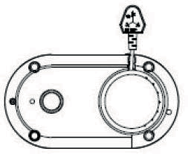
Figure 30

  - CLEANING AND CARE
Clean the appliance after each use.
Never immerse the motor into water. Do not use abrasive products when cleaning. Never pour bleach or other chemical sterilizing solutions/tablets into the appliance.
- Always unplug the appliance and remove the blender jug from the main machine when not in use.
- Remove the jug lid from blender jug.
- Remove the parts of the blade and disassembly as below.
- After each use, wash the blade immediately with water.
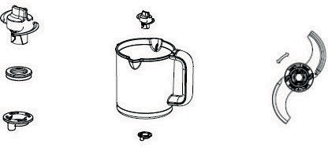
Figure 31 Figure 32 Figure 33

- After each use, clean all parts that have been in contact with food.
Attention: All parts except the main body can be cleaned in dishwasher.
- Use a dry cloth to clean the main body if necessary.
- Check the wate5. r tank and clean it if there is any food inside.
- Check the steam outlet and clean it if there is any foods inside. (see section "steam outlet cleaning").
- Always keep water the tank dry.

  - STEAM OUTLET CLEANING
The steam outlet should be cleaned if the nozzle are blocked Cleaning instructions shown as below.
- Always unplug the appliance
- Add citric acid (vinegar) and water into the tank.
- Cover and turn the water tank cap.
- Tilt the appliance so the steam otulet is upside down, pour the citric acid (vinegar) and water

out from the outlet.
- Empty the water tank and keep it dry

  - TECHNICAL SPECIFICATION Heating power: 700W
Blending power : 120W Voltage: 220-240V
Water tank capacit y: 280ML Blending jug capacity: 900ML Weight: 2.1kg
Unit size: 288x132x212mm

